Site Visit Guide - [insert name of site here]

*[make a copy of this template for each site]*

The Site Visit Guide will be used:

* **by participants to** understand what activities are implemented at the site, how they are connected to IR- and subIR-level results, and to frame questions for beneficiaries and/or sub-awardees
* **by the designated note-taker to** record observations and responses to site-specific learning questions

# Illustrative Questions about resilience to crises:

## EG activity Questions

* How has the COVID-19 pandemic/war in NK/war in Ukraine/sanctions against Russia impacted your work?
* How has it changed your ability to secure necessary inputs?
* How has it changed your ability to secure necessary labor? (Participants may want to ask specifically about women, youth, and other marginalized groups.)
* How has it changed your access to markets (domestic and/or export)?
* How has it changed the prices you can charge for your product?
* Have there been any unexpected benefits?
* What challenges or opportunities do you foresee as these crises unfold or resolve?

## DG activity Questions

* How has the COVID-19 pandemic/war in NK/war in Ukraine/sanctions against Russia impacted your work?
* How has it changed your ability to secure necessary inputs? Labor?
* Has it pulled attention or resources away from your planned activities? Or redoubled your efforts?
* How has it changed the *demographics* of the populations that you serve? (Participants may want to ask specifically about women, youth, and other marginalized groups.)
* How has it changed the *needs* of the populations you serve?
* Have you had difficulty responding to changing demographics and/or needs?
* Have there been any unexpected benefits?
* What challenges or opportunities do you foresee as these crises unfold or resolve?
* How do you anticipate meeting or adapting to these challenges or opportunities?
* What is your strategy for responding to this challenge/these changes?

[Insert activity/site fact sheet or data placemat here - each participant should have a copy of the fact sheet/ data placemat and site questions for reference.]

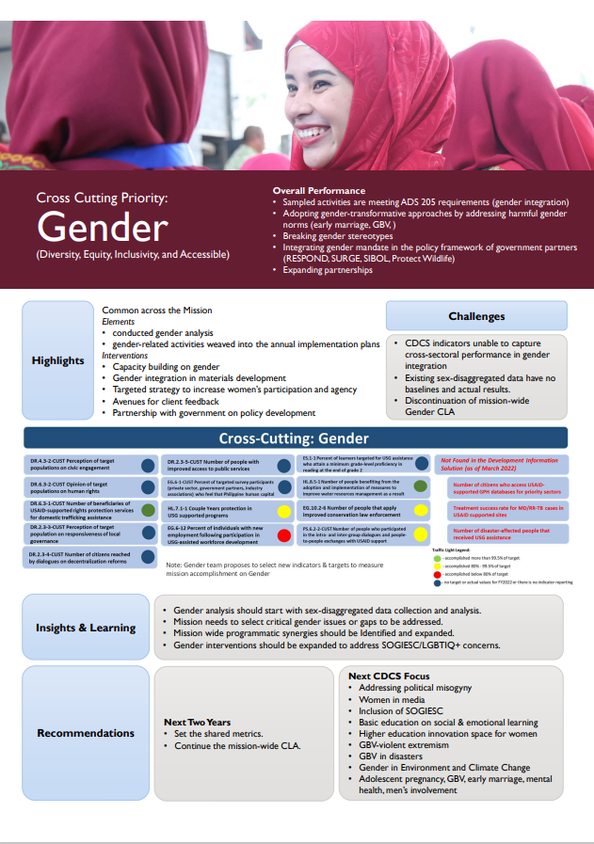

|  |
| --- |
| Example data placemat -This example is summarizing data for a cross-cutting issue from a mission’s CDCS (so, roughly DO level information). **If you want to do a Strategy level PR,** the data placemat for the FBPR site visits would contain some basic information on the site from the activity fact sheet (activity objective, size/lifespan of award, highlighted accomplishments and key issues/challenges), as well as the RF for the DO that the activity contributes to, along with data on IR/subIR level indicators that the activity contributes to, as well as risks, assumptions, and learning questions for the DO. The data placemat is a large piece of paper that contains basic information about the site/activity that places it within the context of the larger DO/Strategy. |